Project Report – “SUMO on Protégé”

Hafeez U. Khan

College of Business - Florida Atlantic University

Prof. Dr. Ravi Shankar

Semantic Web Programming

COP 5859

August 3rd, 2015

Abstract

This is a Project Report for “SUMO Protégé Project”, required for COP 5859 – Semantic Web Programming. This project report will elaborate how I achieved my objectives during this project and class about the SUMO Protégé Ontology? The purpose of this project is to utilize the SUMO Ontology and successfully upload the application with correct hierarchy. Initial load resulted a flat file which was amended according to actual SUMO hierarchy. Due to complexity of code and time factors the SUMO.owl file was not completely transferred to project owl file, named SUMO Hafeez Khan .owl. The concept and knowledge while learning the Semantic Web Programming course was successfully utilized during this project. This project is a good initial step for someone who wants to do research on SUMO.owl ontology.

Table of Contents

Introduction………………………………………………………………………………………..4

Project Scope……………………………………………………………………………………...4

Project Overview…………………………………………………………………………….……4

Project Activities..…………………………………………………………………………………4

Project Solution……………………………………………………………………………………6

Project Challenges ….…………………………………………………………………………….6

Conclusion………………………………………………………………………………………...6

SUMO On Protégé

**Introduction**

The project “SUMO on Protégé” code is located at the link to SUMO in .owl format at <http://www.adampease.org/OP/> , listed under "Documentation and other resources." When SUMO.owl is imported to Protégé, the SUMO ontology is flattened. To run the SUMO.owl successfully using Protégé, find the errors by: (1) Going online and determine if there is a solution; if not, (2) Review the SUMO.owl file to see where the error was made and get it right, or, (3) As a last alternative, import part of the SUMO.owl file and add incrementally the remainder. This process may require the use of Python to systematically achieve the result.

**Project Scope**

The goal of SUMO on Protégé project is to create a SUMO ontology using Protégé. This project encourages to learn the SUMO-The Suggested Upper Merged by: (1) observe SUMO code while running the SUMO ontology file in Protégé, (2) analyze and find errors which are the reason of flat ontology, (3) finding the trend of correct ontology, (4) replacing the non-operational trend with the operational trend, and (5) finally, by run the correct SUMO ontology in Protégé.

**Project Overview**

**Project Manager and Participants**

The “SUMO on Protégé” is a single student project. I, Hafeez Khan will be the only participant of this project.

**Project Deadline**

The deadline for this project is August 3rd, 2015.

**Stakeholders and Project Requestor**

Prof. Dr. Ravi Shankar is the requestor for this project. Prof. Dr. Shankar’s contact information is given as under:

Center of System Integration Director

FAU-Florida Atlantic University

College of Engineering and Computer Science

777 Glades Road – 513 EE (Building 96) Boca Raton, Florida 33431

Tel- 561- 297-3470

Fax (561) 297-2800

Email: [shankar@fau.edu](mailto:shankar@fau.edu)

**Project Activities**

**Data Provision**

I download SOMO.owl from <http://www.adampease.org/OP/SUMO.owl> which was very slow and crashing again and again. I finally downloaded the file from the COP 5859- Semantic Web Programming Course’s webpage at Black Board by using the right click and safe as option.

**Tools and Materials**

To use Python and Protégé, I downloaded Python3.4.3 from <https://www.python.org/downloads/> , and Protégé 4.3 from <http://protege.stanford.edu/products.php#desktop-protege>.

**Project Method**

By followed my project plan (Appendix E), on, 18th July 2014, I searched the project solution online using the Google, Yahoo, and MSN search engine but could not get any solution. I also searched online books, blogs and project reviews but there was no hint for any solution. I also searched the Github and did not find any clue. After that I started working on SUMO.owl file to find errors. I opened SUMO.owl file on Protégé and try to look the class ontology by using OWL Viz feature of Protégé. The result was a flat file. I adopted following strategy:

**Phase I.** Incrementally, I transferred the SUMO.owl code to file named “My SUMO Test.owl”. I transferred around 45% of the code and realized that the SUMO hierarchy I am getting in Protégé using OWL Viz feature is totally different than mentioned on the SUMO website as shown in appendix C. Because, according to SUMO website the SUMO.owl hierarchy has two main classes (1) Physical and (2) Abstract (Appendix A).

**Phase II.** After getting the wrong hierarchy result, I observed the SUMO project class hierarchy at <http://virtual.cvut.cz/kifb/en/toc/229.html> (Appendix A). This link gave me complete picture of SUMO Project classes. I found that there are two main classes under entity, (1) Physical, (2) Abstract. Under Physical class there are two sub classes (1) object (2) and process. While under abstract class there are seven sub classes (1) [quantity](http://virtual.cvut.cz/kifb/en/concepts/_quantity.html), (2) [attribute](http://virtual.cvut.cz/kifb/en/concepts/_attribute.html), (3) [set or class](http://virtual.cvut.cz/kifb/en/concepts/_set_or_class.html), (4) [relation](http://virtual.cvut.cz/kifb/en/concepts/_relation.html), (5) [proposition](http://virtual.cvut.cz/kifb/en/concepts/_proposition.html), [(6)](http://virtual.cvut.cz/kifb/en/concepts/_graph.html) and (7) [graph element](http://virtual.cvut.cz/kifb/en/concepts/_graph_element.html).

**Project Code Pattern Finding**. To find the error and trend in SUMO.owl file I started making main class and sub classes using protégé. I found the error on first three lines of SUMO.owl class definition .RDF code as mentioned:

**Wrong Code of Main Class “Physical”.** This is the wrong pattern code found on SUMO.owl file for first main class “Physical”:<owl:Class rdf:ID="Physical"> <rdfs:isDefinedBy rdf:resource="http://www.ontologyportal.org/SUMO.owl"/> <rdfs:subClassOf rdf:resource="#Entity"/>

**Correct Code of Main Class “Physical”.** This is the correct patter which I observed after making first main “Physical class” in Protégé. <!-- http://www.semanticweb.org/hafeez/ontologies/2015/6/untitled-ontology-12#Physical --> <owl:Class rdf:about="http://www.semanticweb.org/hafeez/ontologies/2015/6/untitled-ontology-12#Physical"> <rdfs:subClassOf rdf:resource="&owl;Thing"/>

**Wrong Code of Main Class “Abstract”. ”.** This is the wrong pattern code found on SUMO.owl file for second main class “Abstract”:<owl:Class rdf:ID="Abstract"> <rdfs:isDefinedBy rdf:resource="http://www.ontologyportal.org/SUMO.owl"/> <rdfs:subClassOf rdf:resource="#Entity"/>

**Correct Code of Main Class “Abstract”.** This is the correct patter which I observed after making second main “Abstract” class” in Protégé. <!-- http://www.semanticweb.org/hafeez/ontologies/2015/6/untitled-ontology-12#abstract --> <owl:Class rdf:about="http://www.semanticweb.org/hafeez/ontologies/2015/6/untitled-ontology-12#abstract"> <rdfs:subClassOf rdf:resource="&owl;Thing"/>

**Project Solution**

The best solution I found was to observe the SUMO website class hierarchy and then make the classes and subclasses using Protégé. I divided the hierarchy in levels for main classes Physical and Abstract level One (Appendix B). Then in level two of hierarchy I included subclasses of main classes and so on. I followed following steps to make SUMO ontology:

**Step 1**. After knowing about the hierarchy mentioned on SUMO website I made those classes using Protégé and named “SUMO Hafeez Khan.owl” to my project file.

**Step 2.** I opened both SUMO Hafeez Khan.owl and SUMO.owl file in Notepad to amend the code.

**Step 3**. I searched for the specific class code on main SUMO.owl file for the classes which I made using Protégé. Since, I knew that first three lines of the code are wrong pattern and already in the code which I made, I copied the rest of the class code and pasted with in related class code’s tag.

**Step 4**. After pasting the code I ran SUMO Hafeez Khan.owl file in protégé to make sure my pasted code is not conflicting with the hierarchy and confirmed the class relation using OWL Viz feature (Appendix H,I,J and K)..

**Step 5**. If there was an error in class relation diagram then I used Ctrl+Z function on my SUMO Hafeez Khan .owl file to undo the changes and save the file to avoid wrong code in my project file.

**Step 6**. I made all the subclasses in my project file SUMO Hafeez Khan .owl keeping in view the SUMO hierarchy from the SUMO website.

**Project Challenges Lack of SUMO Information**

SUMO’s ontology related material is not available in excess and very limited information was available online related to SUMO ontology which required extra research on the topic to find the solution. This factor affected the time factor. Inaccessibility of information material was a major challenge that affected the outcome of the project.

**Complexity of SUMO.owl**

SUMO.owl file composed a complex ontology code which was creating a flat ontology while running using the Protégé. Due to the complexity of the SUMO ontology code it was hard to use Python code to write code and find to replace the correct code for the project. Complexity of SUMO.owl was a challenging and extra time consuming situation to transfer the class related part of the code to the project file by copy and paste option which affected the outcome of the project.

**Time Factor**

The major risk factor affected this project was time. Besides attending three graduate level courses during summer semester, an extra amount of time had been given to complete this project. To complete the project 118 hours (Appendix H) were utilized. In case of extra time available, this project could be completed with much better results.

**Conclusion**

Initially, after getting flat file while running the SUMO.owl file in Protégé, I found the correct pattern of the code. I tried to replace the error code with right code but the complexity of SUMO.owl was a major challenge to use Python. By using the project hierarchy mentioned on SUMO ontology website, I made a new project file SUMO Hafeez Khan .owl which was creating correct hierarchy (Appendix I,J,K and L). I transferred SUMO.owl file’s code to project file by copy and paste option. Since, the code has more than 800K lines of code, it was challenging to transfer 100% code to new file but the project ended with a good amount of information to further proceed on SUMO ontology’s research. However, if someone wants to research on this topic my new code and this project report is a right way to start the project.

**Appendixes**

Appendix A

SUMO Hierarchy

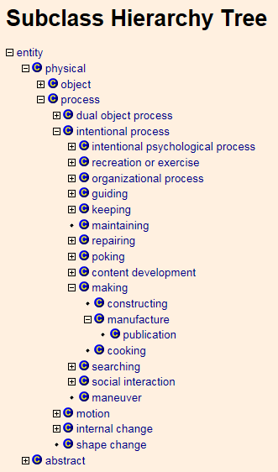

Appendix B

Hierarchy levels

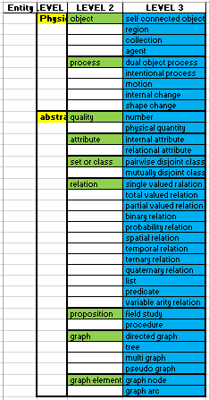

Appendix C

Wrong SUMO Hierarchy

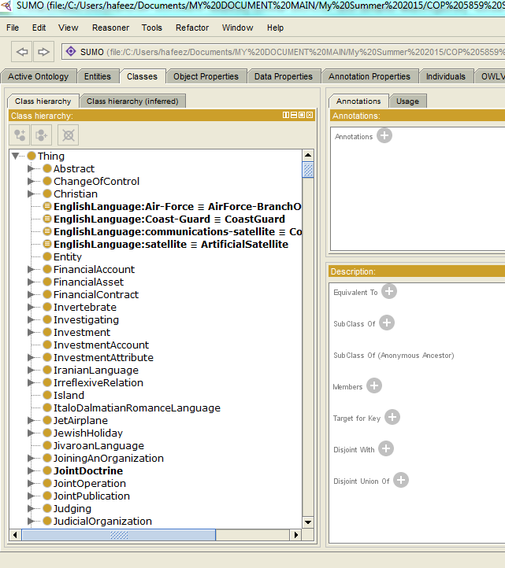

Appendix D

Correct SUMO Hierarchy

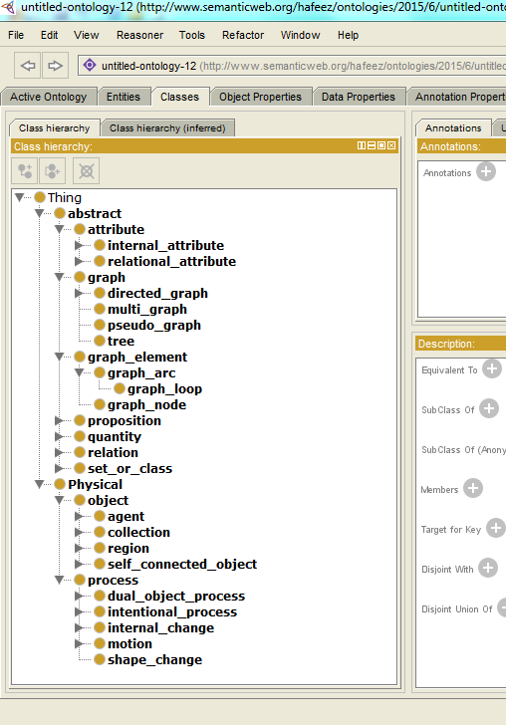

Appendix E

Project Flow Diagram

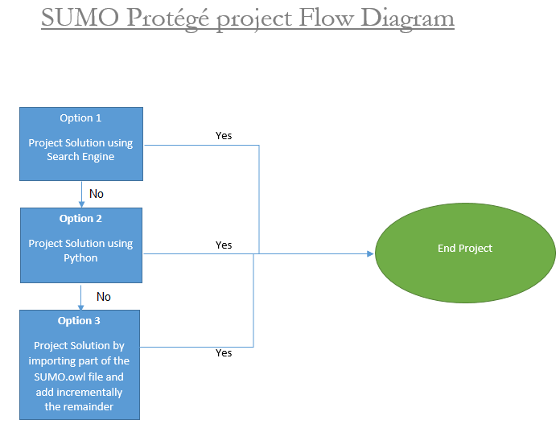

Appendix F

Project Gantt Chart

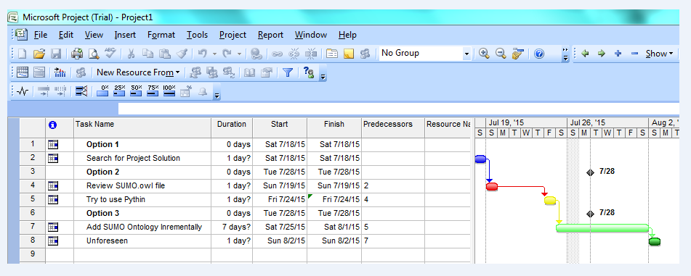

Appendix G

Project Network Diagram

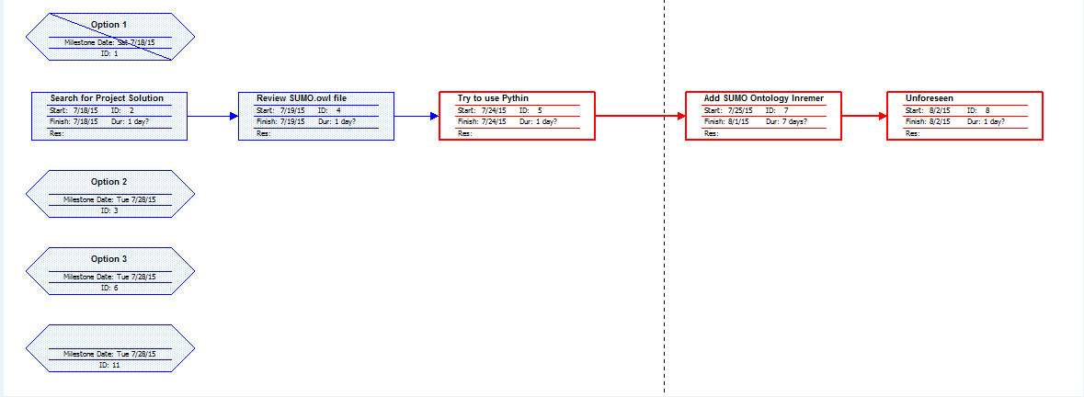

Appendix H

Project Resource Chart

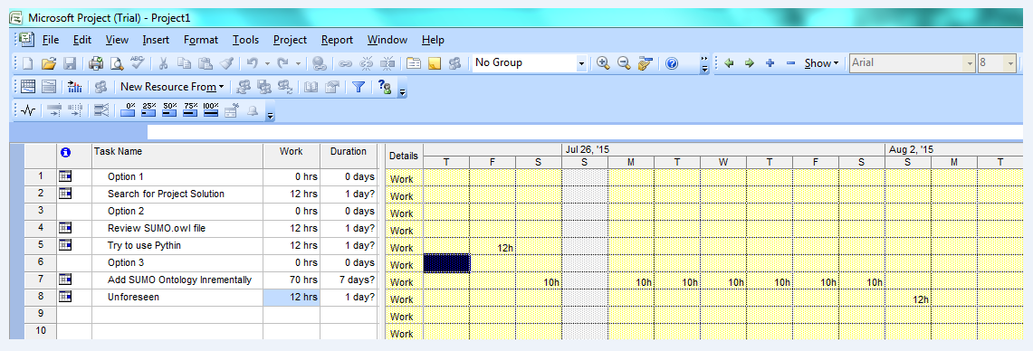

Appendix I

Abstract Main Class

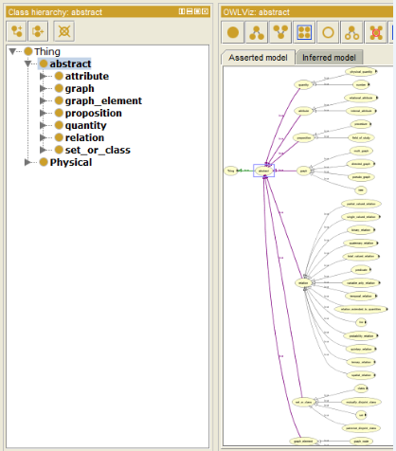

Appendix J

Abstract Sub Classes

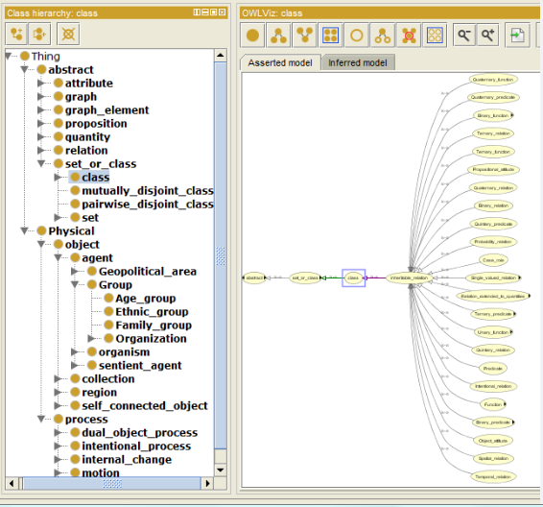

Appendix K

Physical Main Class

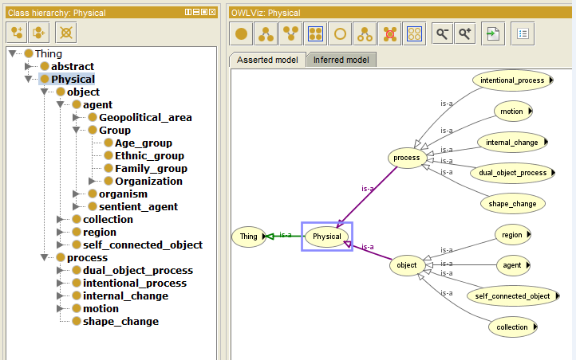

Appendix L

Physical Sub Classes

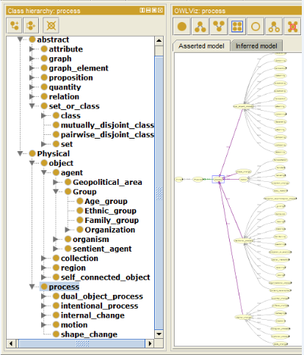

References

Suggested Upper Merged Ontology (SUMO). (2015, July 7). Retrieved from http://www.adampease.org/OP/index.html

Pease, A. (2002). The Suggested Upper Merged Ontology: A Large Ontology for the Semantic Web and its Applications. Retrieved from https://www.aaai.org/Papers/Workshops/2002/WS-02-11/WS02-11-011.pdf